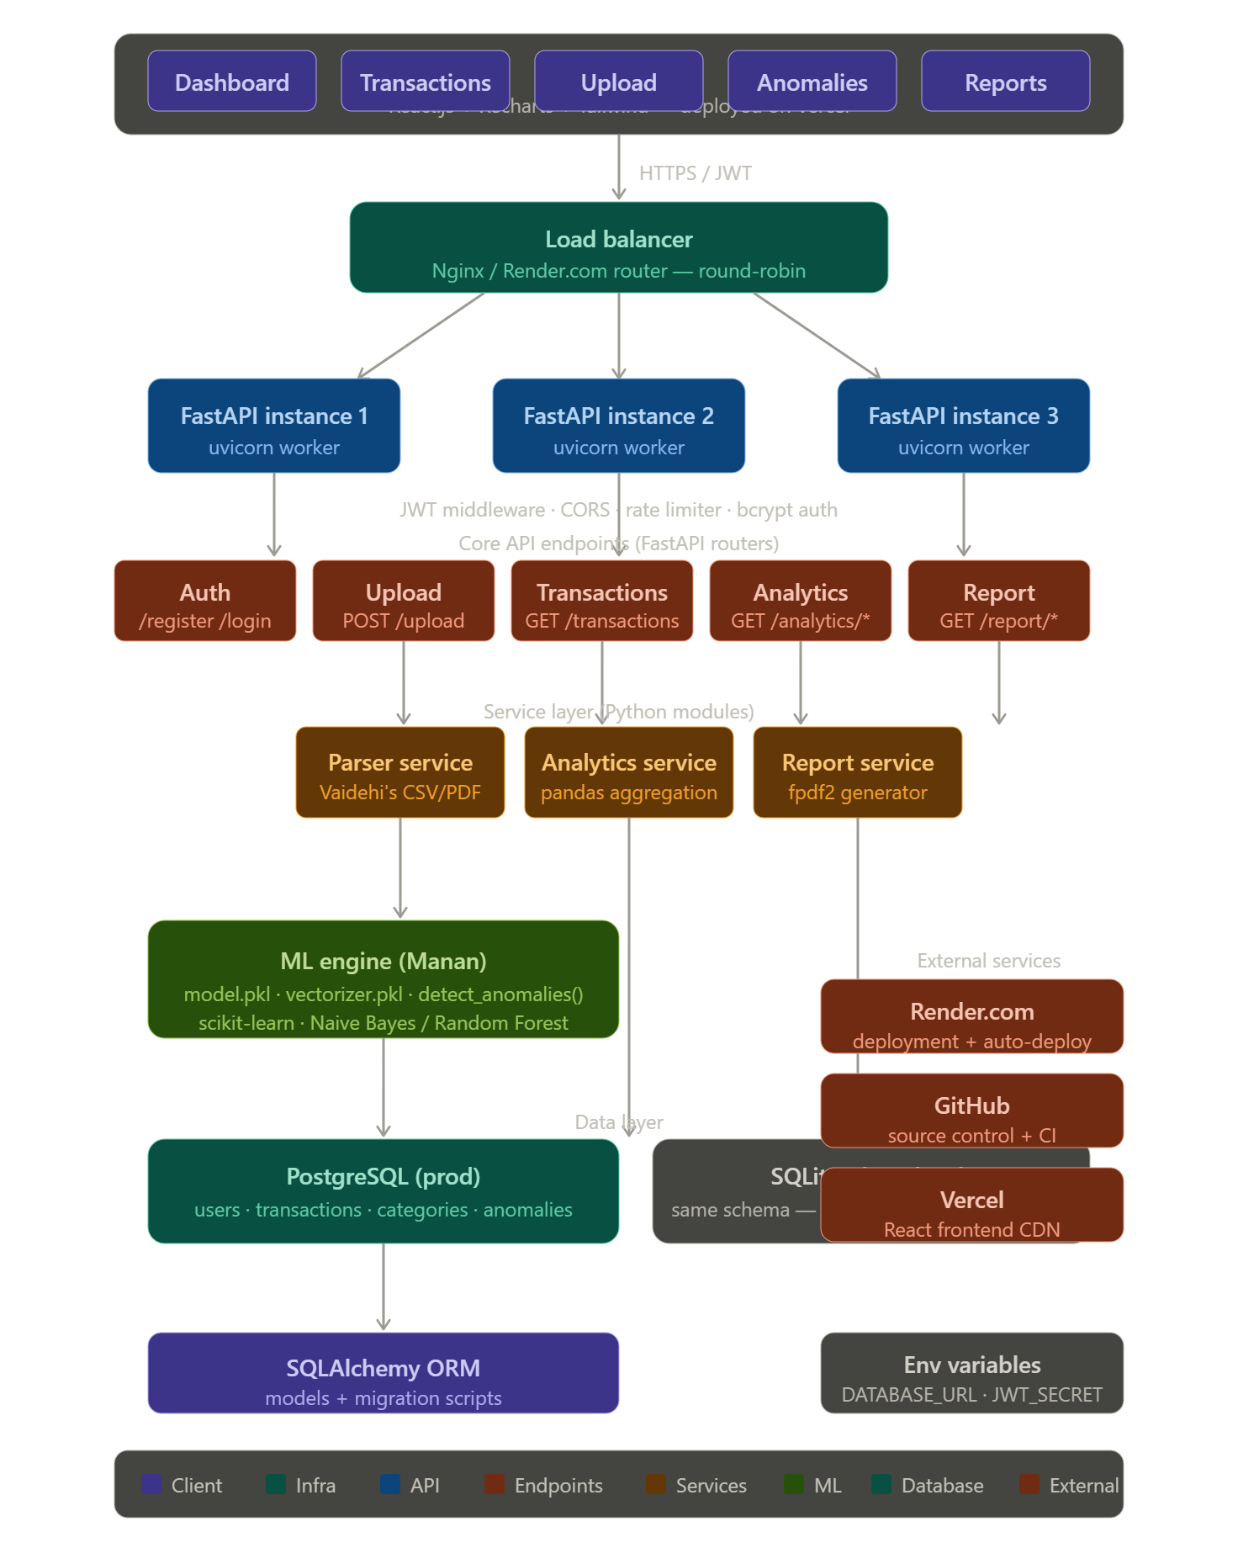
Here's the full system design for SpendLens. Let me walk you through the key architectural decisions layer by layer.
Client layer (Pratha's domain) — React on Vercel serves 5 pages. Every request goes out with a JWT in the Authorization header via Axios. Vercel's CDN handles static asset delivery, so the frontend is always fast regardless of what the backend is doing.
Load balancer — This is placed between the client and your FastAPI instances. On Render.com's free tier you get one instance, but the architecture is designed so you can horizontally scale to 2-3 workers just by changing your render.yaml. Nginx handles round-robin routing and can also terminate SSL so your FastAPI instances stay pure HTTP internally.
Three FastAPI instances — Each runs as a uvicorn worker. JWT middleware runs on every request before it reaches any router. CORS is configured once in main.py with ALLOWED_ORIGINS from your env vars.
Core API endpoints — Organized as FastAPI routers (separate files in /backend/routers/). Auth, Upload, Transactions, Analytics, Report. Each router is independently testable via Postman.
Service layer — This is where Vaidehi's parser, pandas analytics logic, and fpdf2 report generation live as importable Python modules. The Upload endpoint calls the parser, then immediately kicks off ML prediction, then writes to DB — all in one request.
ML engine — model.pkl and vectorizer.pkl are loaded once at startup (lifespan event in FastAPI) and stay in memory. Every upload triggers a batch predict() call, and detect_anomalies() runs as a post-processing step before saving to the DB.
Database layer — SQLite for local dev, PostgreSQL for production — swapped entirely via the DATABASE_URL env variable with zero code changes. SQLAlchemy ORM abstracts the difference.

